 | RIVER VALLEY HIGH SCHOOL  YEAR 6 PRELIMINARY EXAMINATION

CANDIDATE NAME
CLASS | 6
CENTRE NUMBER | S |  |  |  |  |  |  |  | INDEX NUMBER

H2 CHEMISTRY |  |  | 9647/01
Paper 1 Multiple Choice |  |  | 22 September 2010  1 hour
Additional Materials: | Multiple Choice Answer Sheet  Data Booklet
READ THESE INSTRUCTIONS FIRST

Write in soft pencil.
Do not use staples, paper clips, highlighters, glue or correction fluid.
Write your name, class, Centre number and index number on the Answer Sheet in the spaces provided.

There are forty questions on this paper. Answer all questions. For each question there are four possible answers A, B, C and D.
Choose the one you consider correct and record your choice in soft pencil on the separate Answer Sheet.

Read the instructions on the Answer Sheet very carefully.

Each correct answer will score one mark. A mark will not be deducted for a wrong answer.
Any rough working should be done in this booklet.

________________________________________________________________________
This document consists of 17 printed pages and 1 blank page.

Section A

For each question there are four possible answers, A, B, C and D. Choose the one you consider to be correct.

1 | 25.0 cm³ of 0.05 mol dm⁻³ KClO₄(aq) required 50.0 cm³ of 0.20 mol dm⁻³ TiCl₃(aq) to reach end-point. Given that Ti(III) ion is oxidised to Ti(IV) ion in this reaction, which one of the following formulae represents the reduction product of the ClO₄⁻ ion?
 | A | Cl ⁻ | B | ClO⁻
 | C | ClO₂⁻ | D | ClO₃⁻

2 | The table below gives the successive ionisation energies for an element X.  What could be the formula of the chloride of X?
   | 1st | 2nd | 3rd | 4th | 5th | 6th
  ionisation energy /kJ mol⁻¹ | 950 | 1800 | 2700 | 4800 | 6000 | 12300
 | A | XCl | B | XCl₂
 | C | XCl₃ | D | XCl₄

3 | A sample of m g of a compound was vaporised in a gas syringe. The vapour occupied V dm³ at T °C and p atm.  What is the relative molecular mass of the compound, M_{r},?
 | A | 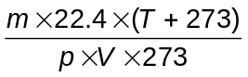
 | B | 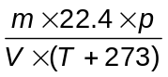
 | C | 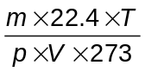
 | D | 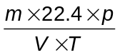

4 | Which of the following does not have a planar structure?
 | A | NO₃⁻
 | B | H₂C₂O₄
 | C | ICl₄⁻
 | D | H₂C=C=CH₂

5 | Which quantity would best indicate the relative strengths of the hydrogen bonds between the molecules in liquid hydrogen halides?
 | A | enthalpy changes of vapourisation
 | B | enthalpy changes of formation
 | C | enthalpy changes of solution
 | D | bond dissociation energies

6 | Which equation represents the standard enthalpy change of atomisation of bromine?
 | A | Br₂(l) → 2Br(g)
 | B | Br₂(g) → 2Br(g)
 | C | ½Br₂(l) → Br(g)
 | D | ½Br₂(g) → Br(g)

7 | In the dry cell battery, one electrode is the zinc casing. The other electrode is a carbon rod, at which MnO₂ and NH₄⁺ ions are converted into MnO(OH) and NH₃.  What is the decrease in mass of the zinc electrode when 0.2 g of MnO₂ is used up?
 | A | 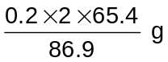
 | B | 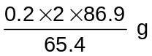
 | C | 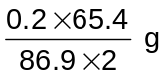
 | D | 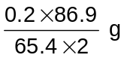

8 | It is often said that the rate of a typical reaction is roughly doubled by raising the temperature by 10 °C.  What of the following statements best explains this observation?
 | A | Raising the temperature by 10 °C doubles the average energy of each reactant particle.
 | B | Raising the temperature by 10 °C doubles the average speed of the reactant particles.
 | C | Raising the temperature by 10 °C doubles the frequency of collisions of the reactant particles.
 | D | Raising the temperature by 10 °C doubles the number of reactant particles having more than a certain minimum energy.

9 | The reaction of hydrogen peroxide with iodide ions in an acidic solution can be monitored by an initial rates method.  H₂O₂(aq) + 2H⁺(aq) + 2I ⁻(aq) → 2H₂O(l) + I₂(aq)  The rate equation was found to be as follows:  Rate = k [H₂O₂][I ⁻]  What could be the mechanism of this reaction?
 | A | H₂O₂ + H⁺ → H₂O + OH⁺ (fast)  OH⁺ + 2I ⁻ + H⁺ → H₂O + I₂ (slow)
 | B | H₂O₂ + I ⁻ → H₂O + IO⁻ (slow)  IO⁻ + H⁺ → HIO (fast)  HIO + H⁺ + I ⁻ → H₂O + I₂ (fast)
 | C | 2H⁺ + 2I ⁻ → 2HI (fast)  2HI + H₂O₂ → 2H₂O + I₂ (slow)
 | D | H₂O₂ + I ⁻ + H⁺ → H₂O + HIO (fast)  HIO + I ⁻ → OH⁻ + I₂ (slow)  OH⁻ + H⁺ → H₂O (fast)

10 | An equilibrium can be represented by the following equation.  P(aq) + Q(aq)  2R(aq) + S(aq)  In a certain mixture, the equilibrium concentration of Q is 10 mol dm⁻³.  What will the new equilibrium concentration of Q be if 5 mol of pure Q is dissolved in the mixture?
 | A | between 10 mol dm⁻³ and 15 mol dm⁻³
 | B | between 5 mol dm⁻³ and 10 mol dm⁻³
 | C | 15 mol dm⁻³
 | D | 10 mol dm⁻³

11 | In an acid-base titration, a 0.20 mol dm⁻³ solution of a base is added to 25 cm³ of a 0.10 mol dm⁻³ solution of an acid.  The pH value of the solution is plotted against the volume of base added, V, as shown in the diagram.  V /cm³  1  3  5  7  9  11  13  12.5  25.0  pH  This diagram could represent a titration between
 | A | CH₃COOH(aq) and NH₃(aq).
 | B | HCl(aq) and Ba(OH)₂(aq).
 | C | H₂SO₄(aq) and NaOH(aq).
 | D | HNO₃(aq) and NH₃(aq).

12 | An element X is a solid with a low conductivity at room temperature. It forms only one chloride, which is a liquid at room temperature and a non-conductor of electricity. The chloride of X hydrolyses in water, forming a white solid and a strongly acidic solution.  Which of the following elements could X be?
 | A | aluminium
 | B | phosphorus
 | C | silicon
 | D | sulfur

13 | Which of the following statements about Group II elements from Mg to Ba is incorrect?
 | A | The melting point of the oxides increases down the group.
 | B | The reactivity of the elements with chlorine gas increases down the group.
 | C | The decomposition temperature of the nitrates increases down the group.
 | D | The volume of gases formed per gram of carbonate decomposed decreases down the group.

14 | Which property of the oxides of Period 3 elements (sodium to phosphorus) decreases from Na₂O to Al₂O₃ and also from SiO₂ to P₄O₁₀?
 | A | melting point
 | B | covalent character
 | C | pH of the resultant solution when the oxide is mixed with water
 | D | solubility in aqueous alkali

15 | An aqueous solution containing both potassium chloride and potassium iodide is treated with an excess of aqueous silver nitrate. The precipitate formed is filtered off and washed with distilled water. The precipitate is then shaken with aqueous ammonia and filtered off again.  Which ion is not present in the final filtrate?
 | A | chloride
 | B | iodide
 | C | potassium
 | D | silver

16 | Consider the following reaction :  Cl₂(g) + 2H₂O(l) + SO₂(g) → 2HCl(aq) + H₂SO₄(aq)  Cl₂(g) + H₂S(g) → 2HCl(aq) + S(s)  SO₂(g) + 2H₂S(l) → 2H₂O(l) + 3S(s)  What can be deduced about the strength of the three reacting gases as reducing agents?
 |  | strongest |  | weakest
 | A | hydrogen sulfide | chlorine | sulfur dioxide
 | B | chlorine | sulfur dioxide | hydrogen sulfide
 | C | hydrogen sulfide | sulfur dioxide | chlorine
 | D | sulfur dioxide | hydrogen sulfide | chlorine

17 | Which set of data correctly illustrates copper as a typical transition element and calcium as an s-block element?
 |  | property | copper | calcium
 | A | density /g cm⁻³ | 8.92 | 1.54
 | B | electrical conductivity /relative units | 9.6 | 85
 | C | melting point /°C | 810 | 1083
 | D | metallic radius /nm | 0.197 | 0.117

18 | Punicalagin is a potent antioxidant found in pomegranates.  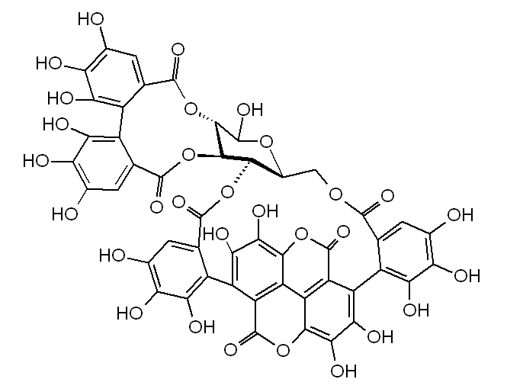  How many chiral carbons are there in a molecule of punicalagin?
 | A | 4 | B | 5
 | C | 6 | D | 7

19 | Which of the following is the least likely product formed in the termination step in the reaction of ethane with chlorine in the presence of uv light?
 | A | HCl | B | CH₃CH₂Cl
 | C | CH₃CHCl₂ | D | CH₃CH₂CH₂CH₃

20 | What is the number of isomers of C₆H₁₂ obtained when the molecule of CH₃CH₂C(CH₃)BrC₂H₅ undergoes dehydrohalogenation (elimination of HBr)?
 | A | 2 | B | 3
 | C | 4 | D | 5

21 | Which of the following shows the correct sequence of compounds arranged in order of decreasing ease of attack by CN⁻?
 | A | C₆H₅COC₆H₅, CH₃CH₂COCH₃, CH₃CHO
 | B | HCHO, CHCl₂COCH₃, CH₃COC(CH₃)₃
 | C | CH₃CH₂COCH₂CH₃, C₆H₅CHO, CH₃COCH₃
 | D | CH₂FCHO, HCHO, CH₃CHO

22 | Aldehydes and ketones are produced industrially by the catalytic oxidation of alkenes. For example, ethanal is manufactured from ethene as shown.  catalysta  H₂C=CH₂ + ½ O₂ ⎯⎯⎯⎯→ CH₃CHO  The process is also used industrially with but-2-ene, CH₃CH=CHCH₃.  Which compound is obtained from but-2-ene?
 | A | CH₃CH₂CHO | B | CH₃COCH₂CH₃
 | C | CH₃CH₂CH₂CHO | D | (CH₃)₂CHCHO

23 | What is the type of reaction mechanism for both step 1 and step 2 in the reaction scheme shown below?  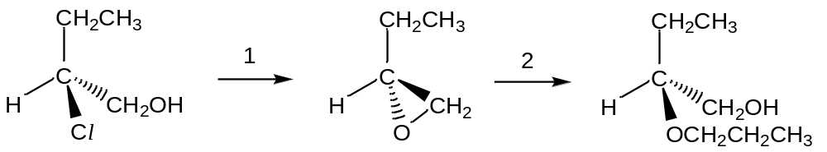  Step 1: NaOH, heat under reflux  Step 2: CH₃CH₂CH₂OH, NaOH, heat
 | A | bimolecular nucleophilic substitution (S_{N}2)
 | B | unimolecular nucleophilic substitution (S_{N}1)
 | C | electrophilic addition
 | D | electrophilic substitution

24 | Which of the following compounds is expected to form an aqueous solution with the highest pH?
 | A | CH₃NH₂
 | B | (CH₃)₂NH
 | C | 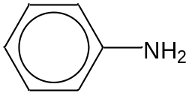
 | D | 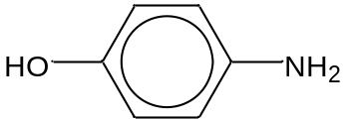

25 | Acidified potassium dichromate(VI) of concentration 1 mol dm⁻³ was added in parts to three separate test-tubes containing 10 cm³ of 1 mol dm⁻³ of unknown solutions X, Y and Z respectively. Each mixture was warmed and the observations are recorded below.  Which of the following could be the identities of X, Y and Z?
   | colour observed upon warming when
  solution | 1st part of 3.3 cm³ of K₂Cr₂O₇ was added | 2nd part of 3.3 cm³ of K₂Cr₂O₇ was added
  X | orange | orange
  Y | green | orange
  Z | green | green
 |  | X | Y | Z
 | A | C₆H₅CH₂OH | CH₃CH₂CH₂OH | CH₃CH₂CH₂CHO
 | B | CH₃CH₂CH₂CH₃ | CH₃C(OH)CHCH₃ | CH₃CHCHCH₂OH
 | C | CH₃CH₂CH₂COOH | CH₃CH₂CH₂CHO | CH₃CH₂COCH₃
 | D | (CH₃)₂C(OH)CH₂CH₃ | CH₃CH(OH)CH₂CH₃ | CH₃CH₂CH₂OH

26 | Which of the following reagents will give a colourless homogeneous solution when added to phenol?
 | A | aqueous bromine
 | B | aqueous sodium carbonate
 | C | aqueous sodium hydroxide
 | D | concentrated nitric acid

27 | Dichlorodifluoromethane, CCl₂F₂, is widely used in aerosol propellants and as a refrigerant.  Which statement helps to explain why dichlorodifluoromethane is chemically inert?
 | A | The carbon-fluorine bond energy is large.
 | B | The carbon-fluorine bond has a low bond polarity.
 | C | Fluorine is highly electronegative.
 | D | Fluorine compounds are non-flammable.

28 | The primary structure of a protein is held together by hydrogen bonds.  Which of the following amino acids would not allow the formation of hydrogen bonds in the primary structure of an α-helix?
 | A | 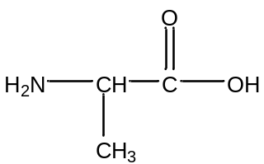 | B | 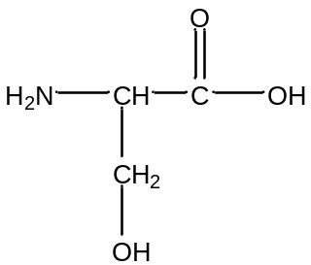
 | C | 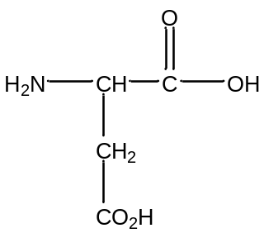 | D | 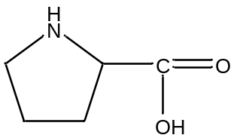

29 | Capsaicin is the compound which gives the ‘hot’ taste to chilli.  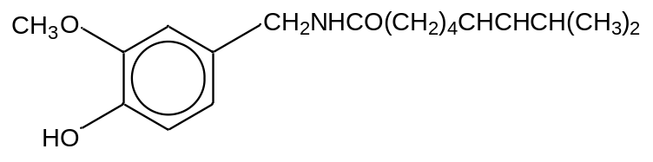  capsaicin  What is the number of sp² and sp³ carbon atoms respectively in a molecule of capsaicin?
 |  | sp² | sp³
 | A | 3 | 15
 | B | 6 | 12
 | C | 7 | 11
 | D | 9 | 9

30 | Compound Z, a dienone, is formed from 4-hydroxyphenol in a reduction process during black-and-white photography.  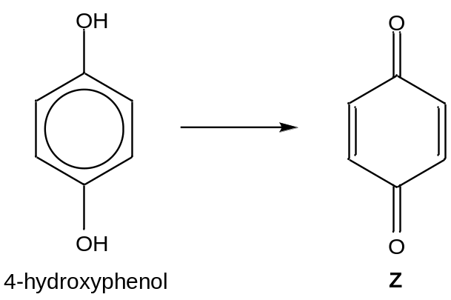  Products A and B are obtained when Z is treated with HCN and a small amount of NaCN.  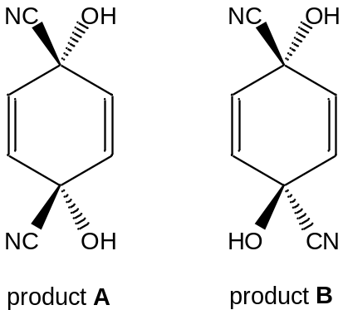  What is the relative ratio of A and B formed and the optical activity of the final solution?
 |  | relative ratio |  | optical activity
 |  | A | B | optical activity
 | A | 1 | 1 | no activity
 | B | 1 | 1 | shows activity
 | C | 1 | 2 | no activity
 | D | 1 | 2 | shows activity

Section B

For each of the questions in this section, one or more of the three numbered statements 1 to 3 may be correct.

Decide whether each of the statements is or is not correct (you may find it useful to put a tick against the statements that you consider to be correct).

The responses A to D should be selected on the basis of

A | B | C | D
1, 2 and 3 are  correct | 1 and 2 only are  correct | 2 and 3 only are  correct | 1 only is  correct

No other combination of statements is used as a correct response.

31 | In which sequences are the molecules quoted in order of increasing bond angle within the molecule?
 | 1 | H₂O NH₃ CH₄
 | 2 | H₂O SF₆ BF₃
 | 3 | CH₄ CO₂ SF₆

32 | Which of the enthalpy changes of the following reactions can only be obtained by application of Hess’ Law?
 | 1 | The hydration of anhydrous copper(II) sulfate to form crystals of CuSO₄.5H₂O.
 | 2 | The formation of methane from its elements.
 | 3 | The combustion of glucose, C₆H₁₂O₆.

33 | Which of the following statements are true for a standard cell set up using the half cells below?
  Ni²⁺(aq)/Ni(s) | E = −0.25 V
  Sn²⁺(aq)/Sn(s) | E = −0.14 V
 | 1 | Electrons flow in the external circuit from Ni to Sn.
 | 2 | The concentration of Sn²⁺(aq) will decrease.
 | 3 | The cell emf is +0.39 V.

The responses A to D should be selected on the basis of

A | B | C | D
1, 2 and 3 are  correct | 1 and 2 only are  correct | 2 and 3 only are  correct | 1 only is  correct

No other combination of statements is used as a correct response.

34 | The equilibrium constant, K_{p}, for the reaction  X(g) + Y(g)  Z(g)  varies with temperature as shown in the diagram below.  K_{p}  T  Which conclusions can be drawn from the given information?
 | 1 | The equilibrium mixture contains a greater proportion of Z at higher pressures.
 | 2 | The equilibrium mixture contains a greater proportion of Z at higher temperatures.
 | 3 | The reaction is endothermic in the forward direction.

The responses A to D should be selected on the basis of

A | B | C | D
1, 2 and 3 are  correct | 1 and 2 only are  correct | 2 and 3 only are  correct | 1 only is  correct

No other combination of statements is used as a correct response.

35 | The diagram below represents the reaction profile of a particular reaction.  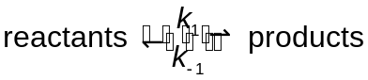  energy  reaction pathway  reactants  products  ΔH  E_{a}  Which of the following will cause both of the rate constants of the forward and backward reactions, k₁ and k₋₁, to be increased?
 | 1 | introducing a catalyst
 | 2 | heating the equilibrium mixture
 | 3 | increasing the concentrations of both the reactants and products

36 | Compounds containing CN⁻ ions are toxic. It is known that 50 mg of CN⁻ ions will be fatal to human beings.  Which of the following compounds do not contain free CN⁻ ions in their aqueous solutions?
 | 1 | CH₃CN
 | 2 | HCN
 | 3 | NH₄CN

The responses A to D should be selected on the basis of

A | B | C | D
1, 2 and 3 are  correct | 1 and 2 only are  correct | 2 and 3 only are  correct | 1 only is  correct

No other combination of statements is used as a correct response.

37 | Ellagic acid is a phenolic acid which is found in abundance in strawberries and raspberries. Ellagic acid can prevent colon and esophageal cancers and is thus often an ingredient added into multi-vitamins.  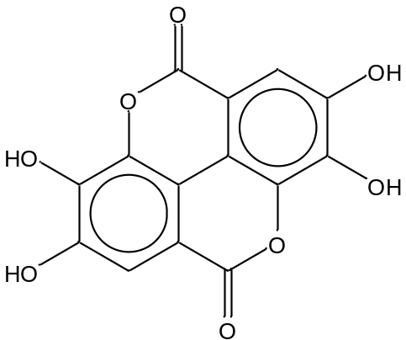  Ellagic acid  Which of the following statements are correct?
 | 1 | 1 mol of Ellagic acid reacts with 4 mol of sodium metal to produce 2 mol of hydrogen gas.
 | 2 | Addition of aqueous bromine results in 2 mol of bromine reacting with 1 mol of Ellagic acid.
 | 3 | On heating with aqueous sodium hydroxide, 2 mol of sodium hydroxide are used up per mole of Ellagic acid.

38 | When compound Y was heated with acidified potassium manganate(VII), a gas was produced which gave a white precipitate when passed into limewater.  Which of the following could Y be?
 | 1 | CH₃OH
 | 2 | C₆H₅CH₂CH₃
 | 3 | CH₃CH₂CHCH₂

The responses A to D should be selected on the basis of

A | B | C | D
1, 2 and 3 are  correct | 1 and 2 only are  correct | 2 and 3 only are  correct | 1 only is  correct

No other combination of statements is used as a correct response.

39 | Which reagents will convert ethanol into bromoethane?
 | 1 | red phosphorus and bromine
 | 2 | sodium bromide and sulfuric acid
 | 3 | aqueous bromine

40 | Which of the following pairs of reagents will give a water-soluble organic product when reacted together?
 | 1 | CH₃CH₂COOH and LiAlH₄
 | 2 | CH₃CH₂COOH and CH₃CH₂NH₂
 | 3 | CH₃CH₂COCl and (CH₃CH₂)₂NH

END OF PAPER
BLANK PAGE

